Integrating Engineering Design Process with Challenge-Based Learning

Speaker: Amy Jameson, CEEMS and RET Exemplar Teacher
Date: Thursday, June 14, 3018
Time: 2:45 – 4:00 p.m.
Venue: University of Cincinnati, Swift Hall, room 608

Prepared by:
Kelly Lindsey, Boone County High School, Florence, Kentucky
RET Participant for Project #3: “Bio-Inspired Optimization of the Multiple Traveling Salesman Problem”

This session was presented by Amy Jameson, CEEMS and RET Exemplar Teacher. The session occurred on June 14, 2018 from 2:45 – 4:00 at the University of Cincinnati in Swift Hall, room 608. The purpose of the session was to instruct current RET participants in the relationship between Engineering Design Process and Challenge-Based Learning.

Ms. Jameson began the session by giving some background information about her teaching experiences and participation in both the CEEMS program (cohort 4, 2015) and RET (2010). Ms. Jameson has been a science teacher for over 30 years and currently teaches at Dater High School in Cincinnati, Ohio (see Figure 1). She related how her science teaching had been influenced and changed by engineering-base teaching strategies. Her work with the Optimization Project in RET focused on using the characteristics of dragonfly wings to adapt airplane wings and make them more efficient. This project has evolved over the past 8 years into the Capstone project for her senior Physics course. Her students use the Engineering Design Process (EDP) to research, design, and test various types of airplane wings. In Figure 2, Ms Jameson shows an example of a student-designed wing.

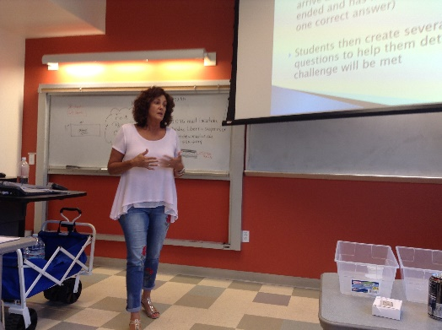  Figure 1: Amy Jameson Introduces the Topic of Melding EDP with CBL | 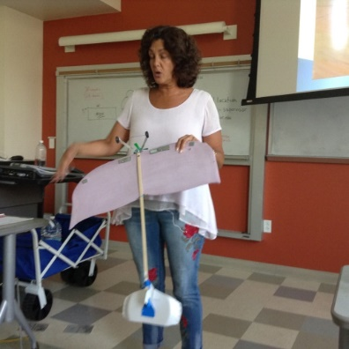  Figure 2: Ms. Jameson with Wing Example

The discussion opened with the beginning of the Engineering Design Process – Identify and Define the task. Ms. Jameson stated that this can be “tricky” at first and that teachers should gently and stealthily guided the students in an exploration of the Essential Question for the given problem. She reminded the group of teachers that the Essential Question needs to be open-ended and subject to many possible solutions. For her senior Capstone project, she guides the student toward the Essential Question “Which bio-inspired features allow a wing to carry the largest payload?”. The discussion with the RET teachers defined an Essential Question to be about “What problem are we trying to solve?” Further discussion introduced Guiding Questions as “What I (students) need to know or do?”. The Guiding Questions fold content into the process and helps students to beat the challenge that is the solution to the Essential Question.

In Ms. Jameson’s wing design project, the students were challenged to build an airplane that would fly and carry the largest payload. The content was absorbed into the background of the Challenge through the EDP steps of research and finding alternatives. The students were given a list of materials and a time frame in which to produce a model. Then all airplanes were tested.

Ms. Jameson also gave some general guidelines for meshing EDP with Challenge-Based Learning (CBL). She mentioned limiting the number of refinements students are allowed to implement. Refinement had to be based on content knowledge and not trial and error. In this way she distinguished between engineering and not just tinkering. She also said that team members should have defined roles such as recorder, materials manager, and timekeeper. These roles helped minimize confusion in the classroom and made each student accountable for portions of the work. She emphasized that communication within each team was one of the most important skills in EDP and CBL.

The session concluded with discussion of some other projects that Ms. Jameson used in class – one in particular involved the design and production of a hot or cold pack that could be used by school athletes. She provided materials and instructions for the RET teachers to make their own hot pack. Figure 3 shows RET teachers gathering materials. Teachers designed their hot packs and then demonstrated them for each other and for Ms. Jameson. During the production stage of the session, Ms. Jameson talked to each team about their design and how they could use the activity as a model for their own classes (see Figure 4).

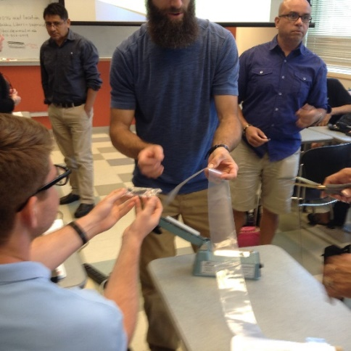  Figure 3: RET Teachers Making Hot Packs | 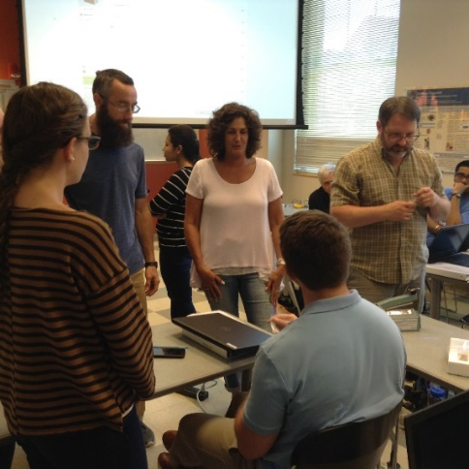  Figure 4: Ms. Jameson Talking with a Team About their Design

The RET teachers gained practical knowledge of the process of integrating EDP with CBL through a PowerPoint, group discussion, and hands-on activity. The combination of presentation by Amy Jameson further prepared the teachers to begin work on their own units.

